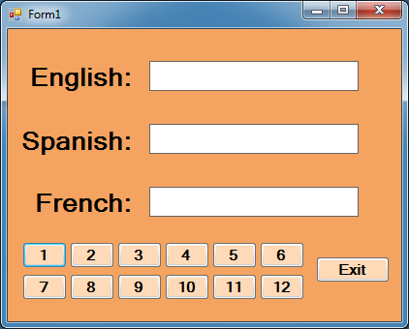  
PO5_Translator

Private Sub btn1_Click(sender As System.Object, e As System.EventArgs) Handles btn1.Click

lblDisplay1.Text = "One"

lblDisplay2.Text = "Uno"

lblDisplay3.Text = "Un"

End Sub

Private Sub btn2_Click(sender As System.Object, e As System.EventArgs) Handles btn2.Click

lblDisplay1.Text = "Two"

lblDisplay2.Text = "Dos"

lblDisplay3.Text = "Deux"

End Sub

Private Sub btn3_Click(sender As System.Object, e As System.EventArgs) Handles btn3.Click

lblDisplay1.Text = "Three"

lblDisplay2.Text = "Tres"

lblDisplay3.Text = "Trois"

End Sub

Private Sub btn4_Click(sender As System.Object, e As System.EventArgs) Handles btn4.Click

lblDisplay1.Text = "Four"

lblDisplay2.Text = "Cuatro"

lblDisplay3.Text = "Quatre"

End Sub

Private Sub btn5_Click(sender As System.Object, e As System.EventArgs) Handles btn5.Click

lblDisplay1.Text = "Five"

lblDisplay2.Text = "Cinco"

lblDisplay3.Text = "Cinq"

End Sub

Private Sub btn6_Click(sender As System.Object, e As System.EventArgs) Handles btn6.Click

lblDisplay1.Text = "Six"

lblDisplay2.Text = "Seis"

lblDisplay3.Text = "Six"

End Sub

Private Sub btn7_Click(sender As System.Object, e As System.EventArgs) Handles btn7.Click

lblDisplay1.Text = "Seven"

lblDisplay2.Text = "Siete"

lblDisplay3.Text = "Setp"

End Sub

Private Sub btn8_Click(sender As System.Object, e As System.EventArgs) Handles btn8.Click

lblDisplay1.Text = "Eight"

lblDisplay2.Text = "Ocho"

lblDisplay3.Text = "Huit"

End Sub

Private Sub btn9_Click(sender As System.Object, e As System.EventArgs) Handles btn9.Click

lblDisplay1.Text = "Nine"

lblDisplay2.Text = "Nueve"

lblDisplay3.Text = "Neuf"

End Sub

Private Sub btn10_Click(sender As System.Object, e As System.EventArgs) Handles btn10.Click

lblDisplay1.Text = "Ten"

lblDisplay2.Text = "Diez"

lblDisplay3.Text = "Dix"

End Sub

Private Sub btn11_Click(sender As System.Object, e As System.EventArgs) Handles btn11.Click

lblDisplay1.Text = "Eleven"

lblDisplay2.Text = "Once"

lblDisplay3.Text = "Onze"

End Sub

Private Sub btn12_Click(sender As System.Object, e As System.EventArgs) Handles btn12.Click

lblDisplay1.Text = "Twelve"

lblDisplay2.Text = "Dove"

lblDisplay3.Text = "Douze"

End Sub

Private Sub btnExit_Click(sender As System.Object, e As System.EventArgs) Handles btnExit.Click

Application.Exit()

End Sub